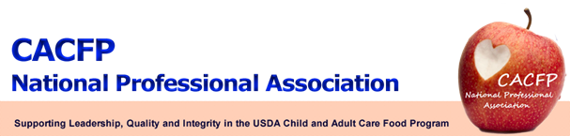

October 2012 Message of the Month

FNS Update

- Memo: Streamlining SFA Participation in CACFP At-Risk Afterschool Program still pending.

- Fact Sheet: Athletic Programs and Afterschool Meal Service was published October 2, 2012.

- Proposed CACFP Meal Patterns: The CACFP Meal Pattern proposed rule is in clearance; has to be reviewed by OMB which can take up to 90 days; no date for release.

- Handbooks: The Adult Day Care Handbook is nearing completion and will be the next handbook that is published. USDA hopes to have all of the handbooks completed in FY 2013 and will provide annual updates to the handbooks.

The handbooks include: At-risk Afterschool Meals *
Family Day Care Home Monitoring *
Adult Day Care
Family Day Care Home Providers
Serious Deficiency
Independent Centers
Sponsors of Centers
Budgets
Multi-State Sponsoring Organizations
State Agency Monitoring

* Handbooks that have been published

FRAC Update

- No current update - things are slowing down due to the up-coming elections.

Workgroup Update

- USDA’s CACFP Technical Assistance Workgroup - Sandra Rhoades will serve as the CACFP NPA representative.

- USDA’s Paperwork Reduction Workgroup – In order to provide administrative relief to state agencies, institutions and facilities, USDA created this workgroup to review and assess paperwork in CACFP and make recommendations for reductions. Ellen Farrell and Benedict Onye will join Diane Hogan as the CACFP NPA representatives.

- Sponsor’s Consortium Workgroup – Lynne Torpy will serve as the CACFP NPA representative.

Website

Continue to check the website at http://www.cacfpnpa.org for the most up-to-date information and minutes from the monthly board meetings.

